**CONTENT**

* **Introduction to Earth’s Magnetic Field**
* **Magnetic Field Lines**
* **Compass Needle and Bar Magnet**
* **Tangent Galvanometer**
* **Experimental Setup and Procedure**
* **Data Analysis and Interpretation**

* **Conclusion**
* **Bibliography**

**Introduction to Earth’s Magnetic Field:**

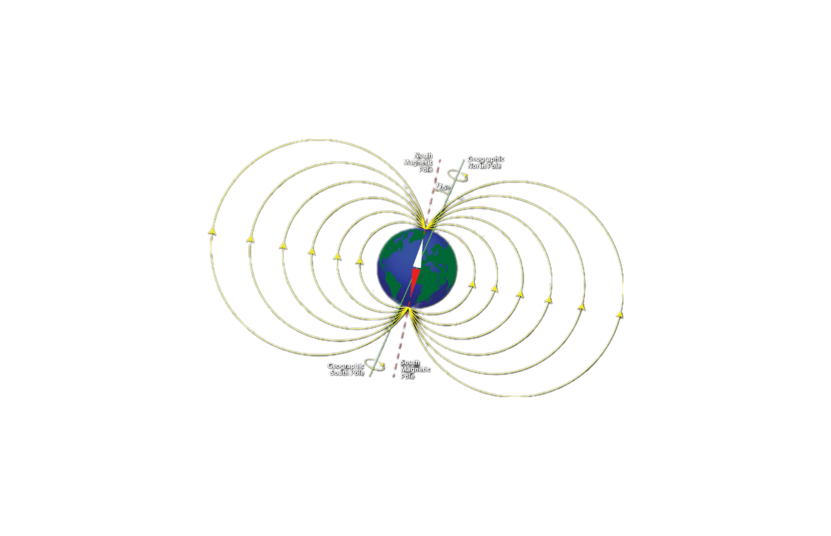

->**Overview to Geomagnetism**:

Geomagnetism is the study of Earth’s magnetic field, which extends from the planet’s core to the space surrounding it, forming the magnetosphere. [This field is primarily dipolar, meaning it has a north and south magnetic pole, similar to a bar magnet, but becomes distorted away from the surface](https://www.britannica.com/science/geomagnetic-field).

The Earth’s magnetic field is generated by the dynamo effect, which involves the movement of molten iron and nickel in the outer core. These movements create electric currents, which in turn produce magnetic fields. [The geomagnetic field is vital for life on Earth as it shields us from harmful solar radiation and cosmic rays](https://www.clearias.com/geomagnetism/).

The field is not static, it changes continuously and undergoes periodic reversals where the magnetic poles switch places. [These reversals are recorded in the remanent magnetization of rocks and can be studied to understand the history of Earth’s magnetic field](https://www.nature.com/subjects/geomagnetism).

[Geomagnetism also encompasses the study of magnetic anomalies, which are variations in the Earth’s magnetic field due to the magnetization of rocks in the crust, and the effects of solar activity, such as geomagnetic storms that can disrupt communication systems and power grids](https://prepp.in/news/e-492-geomagnetism-geography-notes).

The intensity of Earth’s magnetic field is often measured in **Tesla (T)**, which is the International System of Units (SI) for magnetic flux density. However, it is commonly reported in **microteslas (μT)** for Earth’s magnetic field measurements, with 1 T = ( 10^6 ) μT. [Additionally, a smaller unit called **nanotesla (nT)** or **gamma (γ)** is also used, where 1 G (gauss) = ( 10^5 ) nT1](https://en.wikipedia.org/wiki/Earth%27s_magnetic_field)[2](http://www.geomag.bgs.ac.uk/education/earthmag.html)[3](https://www.vedantu.com/physics/earth-magnetic-field). [At the Earth’s surface, the total intensity varies from about 22,000 nT to 67,000 nT](http://www.geomag.bgs.ac.uk/education/earthmag.html)(0.22-0.67 G).

Understanding geomagnetism is crucial for navigation, as compasses rely on the magnetic field to point towards the magnetic north. [It also has applications in studying plate tectonics and the Earth’s interior structure](https://www.britannica.com/science/geomagnetics).

->**Historical significance of Earth’s magnetic field studies:**

The study of Earth’s magnetic field, known as geomagnetism, has a rich history that has significantly contributed to our understanding of the planet. Here are some key historical points:

* **Ancient Navigation**: For centuries, navigators have used the Earth’s magnetic field for direction. The compass, which aligns with magnetic north, was an essential tool for explorers and traders.
* **Discovery of Magnetism**: The ancient Greeks discovered natural magnetic rocks called lodestones, which led to the early study of magnetism.
* **Development of Paleomagnetism**: In the 20th century, scientists began studying the magnetic properties of rocks, known as paleomagnetism. This field has helped us understand how the Earth’s magnetic field has changed over time.
* **Plate Tectonics**: Paleomagnetic studies were crucial in the development of the theory of plate tectonics in the 1950s. [By examining the magnetic signature of ocean floor rocks, scientists could see that continents had moved and were still moving](http://www-gpsg.mit.edu/12.201_12.501/BOOK/chapter3.pdf).
* **Magnetic Reversals**: The discovery that the Earth’s magnetic poles have reversed many times in the past was a groundbreaking finding. This knowledge comes from studying the magnetic orientation of minerals in rocks.
* **Core Dynamics**: Geomagnetism has provided insights into the dynamics of the Earth’s core, where the magnetic field is generated. Understanding the core’s behavior is important for predicting changes in the magnetic field.
* **Space Weather**: The magnetic field protects us from solar wind and cosmic rays. Studies of geomagnetism are important for understanding how solar activity affects our planet. The magnetosphere is Earth’s magnetic force field, extending far into space. It’s crucial because it protects us from the sun’s harmful solar wind and cosmic radiation. Without it, these charged particles would strip away our atmosphere, making Earth uninhabitable. The magnetosphere also shields our satellites and technology from space weather effects, ensuring they operate safely. [It’s like a giant, invisible umbrella that keeps our planet safe and habitable](https://science.nasa.gov/heliophysics/focus-areas/magnetosphere-ionosphere).
* **Dipole:**[The Earth’s magnetic field can be approximated by a dipole (like a bar magnet) tilted at an angle of about **11°** with respect to the Earth’s rotational axis](https://en.wikipedia.org/wiki/Earth%27s_magnetic_field). This tilt is responsible for the difference between magnetic north and true north and is an important factor in navigation and compass use.
* **Modern Applications**: Today, geomagnetic research has applications in navigation, satellite communication, and even archaeology, where it helps date artifacts and ruins.

**Scientific Terms of Geomagnetism**

Geomagnetism is a field rich with scientific terms. Here are some key terms and their meanings:

1. **Geomagnetic Field**: The magnetic field that extends from the Earth’s interior out into space.
2. **Magnetosphere**: The area of space around Earth that is controlled by the Earth’s magnetic field.
3. **Dynamo Effect**: The process by which the Earth’s rotating, conducting core generates a magnetic field.
4. **Magnetic Dipole**: A simple magnetic field with a north and south pole, like that of a bar magnet.
5. **Auroral Electrojets**: Electric currents that flow in the ionosphere at high latitudes and are associated with the aurora.
6. **Ring Current**: A current of charged particles around Earth that influences the magnetic field.
7. **Magnetopause**: The boundary between the Earth’s magnetosphere and the solar wind.
8. **Polar Wandering**: The movement of the Earth’s magnetic poles over geological time.
9. **Geomagnetic Storm**: A temporary disturbance of the Earth’s magnetosphere caused by solar wind.
10. [**Ionospheric Dynamo**: A region where electric currents are generated in the Earth’s ionosphere, affecting the magnetic field](https://www.britannica.com/science/geomagnetic-field).

These terms are fundamental to understanding the science of geomagnetism and its effects on Earth and near-Earth space environments.

**Magnetic field lines**

->**Definition and properties of magnetic field lines:**

**Definition:** Magnetic field lines are imaginary lines that map out the magnetic field around a magnet. They show the direction and strength of the magnetic field.

**Properties:**

1. **Direction**:

The tangent to a magnetic field line at any point gives the direction of the magnetic field at that point.

1. **Strength**:

The closeness or density of the field lines is directly proportional to the strength of the magnetic field.

1. **Poles**:

Magnetic field lines emerge from the north pole and merge at the south pole of a magnet.

1. **Inside a Magnet**:

Inside the magnet, the direction of the magnetic field lines is from the south pole to the north pole.

1. **Never Cross**:

Magnetic field lines never intersect with each other.

1. **Closed Loops**:

Magnetic field lines form closed loops, extending from the north pole to the south pole outside the magnet, and from the south pole to the north pole inside the magnet.

1. [**Vector Nature**:](https://byjus.com/jee/properties-of-magnetic-field-lines/)

At any point, magnetic field lines have both direction and magnitude, making them vector fields.

These properties help us understand how magnetic forces work and predict the behavior of magnetic materials and charged particles in a magnetic field.

**Compass Needle and Bar Magnet**

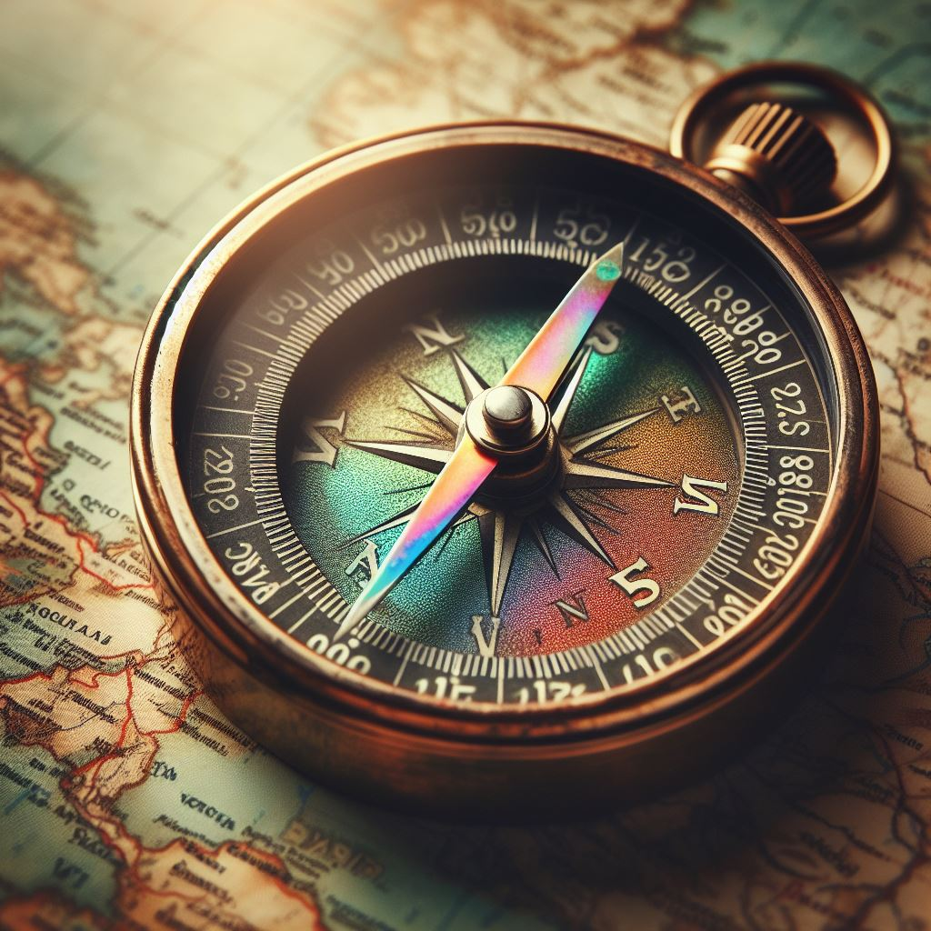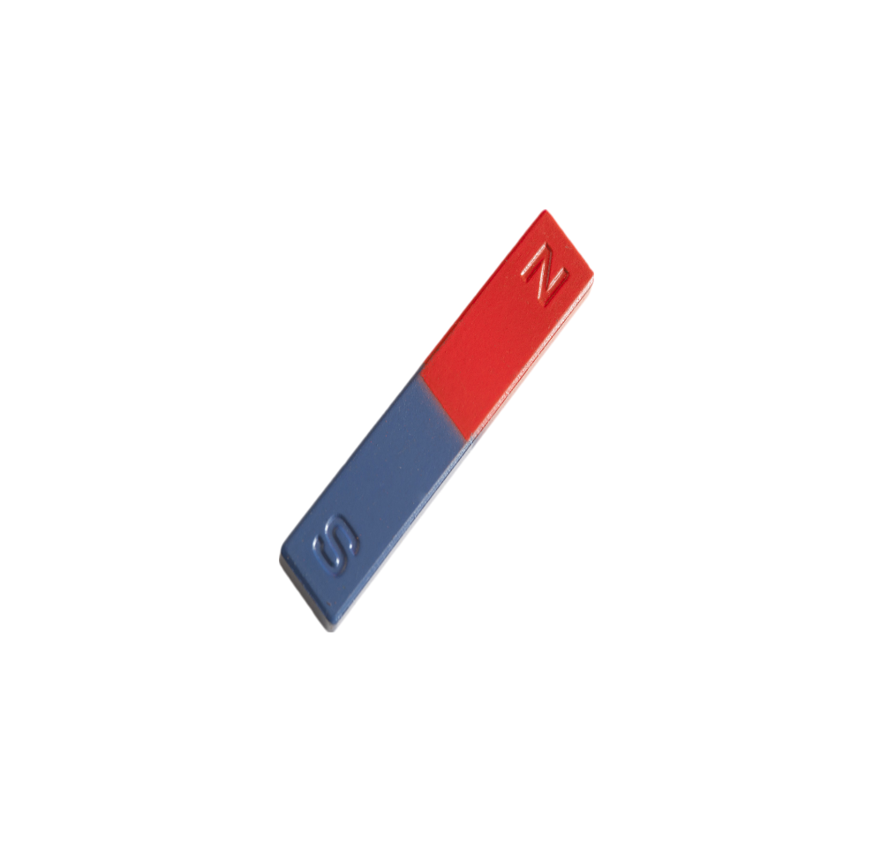

**->The role of the compass in detecting magnetic fields:**

The compass plays a crucial role in detecting magnetic fields. It contains a magnetized needle that aligns itself with the Earth’s magnetic field. When a compass is held level, the needle turns until it settles into its equilibrium orientation, pointing towards the magnetic north. [This is because the Earth behaves like a giant magnet surrounded by a vast magnetic field, with magnetic poles near the geographic North and South Poles](https://www.toppr.com/guides/physics/electronics/magnetic-compass/).

The compass needle’s ability to align with the Earth’s magnetic field makes it an invaluable tool for navigation, allowing people to determine directions based on the Earth’s magnetism. [It’s also used in various scientific and educational settings to explore and measure magnetic fields, especially when paired with basic trigonometry](https://projects.cos.ncsu.edu/physics_ed/Articles/LunkBFieldArticle.pdf).

[In summary, a compass is a simple yet powerful device that utilizes the Earth’s magnetic field to provide directional information, which has been essential for navigation throughout history](https://www.toppr.com/guides/physics/electronics/magnetic-compass/).

**->Using a compass to trace the Earth’s magnetic field:**

To use a compass to trace the Earth’s magnetic field, you can follow these steps:

1. **Prepare Your Compass**: Ensure your compass is flat and free to rotate.
2. **Find a Starting Point**: Begin at a location where you wish to map the magnetic field.
3. **Record the Needle’s Direction**: Note the direction the compass needle points; this is the direction of the local magnetic field.
4. **Mark the Field Lines**: Use a small plotting compass and place it on a piece of paper. Mark the direction the compass needle points.
5. **Move and Repeat**: Move the compass to several positions around your starting point, marking the needle direction each time.
6. **Connect the Dots**: Join the points to show the continuous magnetic field lines.

By following these steps, you’ll create a visual representation of the Earth’s magnetic field in your location. [The compass needle aligns with the horizontal component of the Earth’s magnetic field, allowing you to trace the invisible lines that represent the magnetic force around you](https://www.bbc.co.uk/bitesize/guides/zyx38mn/revision/3).

**Tangent Galvanometer**

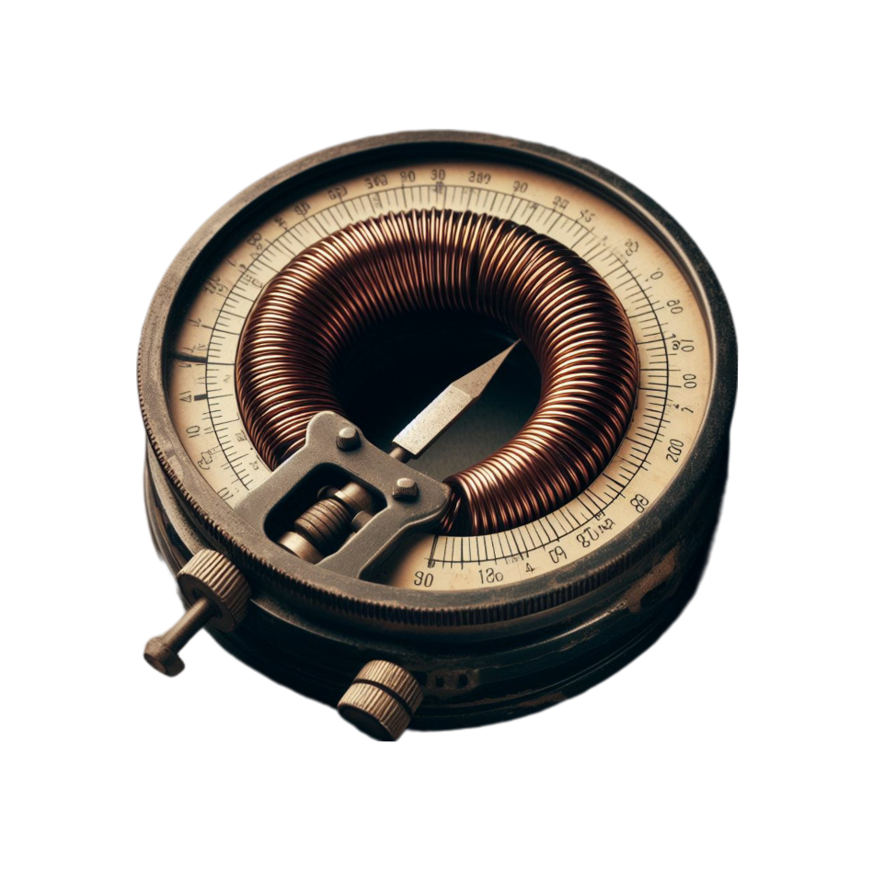

A Tangent Galvanometer is an early measuring instrument used to measure small electric currents. It consists of a coil of insulated copper wire wound on a circular non-magnetic frame. At the center of the coil, there’s a small compass needle or magnetic needle. [The device operates based on the tangent law of magnetism, which relates the magnetic field strength to the angle of deflection of the needle caused by the current passing through the coil](https://unacademy.com/content/ssc/study-material/general-awareness/tangent-galvanometer/).

The construction of a Tangent Galvanometer typically includes:

* A vertical circular coil made of conducting wire
* A horizontal base with leveling screws
* Terminals for connecting the coil to an external circuit
* A small compass needle fixed at the center of the coil
* An aluminum pointer attached to the compass needle, perpendicular to it, which moves over a graduated scale

When a current passes through the coil, it generates a magnetic field at the center, perpendicular to the plane of the coil. The compass needle is then under the influence of two mutually perpendicular magnetic fields: the Earth’s magnetic field and the field generated by the coil. [The angle of deflection of the needle is used to calculate the strength of the current passing through the coil](https://testbook.com/physics/tangent-galvanometer).

**->Principles of operation of a tangent galvanometer:**

The Tangent Galvanometer operates based on the tangent law of magnetism. Here’s a simplified explanation of its principles:

1. [**Magnetic Field Generation**: When an electric current passes through the circular coil of the galvanometer, it produces a magnetic field at the center of the coil, perpendicular to the plane of the coil](https://www.esaral.com/tangent-galvanometer-experiment-construction-working/).
2. **Tangent Law**: The magnetic field produced by the coil (B) and the horizontal component of the Earth’s magnetic field (H) act at right angles to each other. [The compass needle in the galvanometer aligns according to the resultant of these two fields](https://www.esaral.com/tangent-galvanometer-experiment-construction-working/).
3. **Deflection Angle**: The needle comes to rest making an angle (θ) with the horizontal component of the Earth’s magnetic field. [According to the tangent law, (B = Htan(θ))](https://www.toppr.com/content/story/amp/tangent-galvanometer-45576/).
4. **Current Measurement**: The angle of deflection (θ) is used to calculate the strength of the current passing through the coil. [The relationship between the current (I), the galvanometer constant (G), and the reduction factor (K) is given by (I=(H/G)tan(θ)) or (I = K.tan(\theta))](https://gkscientist.com/tangent-galvanometer/).

[This allows the Tangent Galvanometer to measure small electric currents by observing the deflection angle of the compass needle](https://gkscientist.com/tangent-galvanometer/).

**Experimental Setup and Procedure**

**->Setting up the compass and bar magnet experiment:**

A basic procedure for setting up a compass and bar magnet experiment:

1. **Materials Needed**: A bar magnet, a compass, a ruler, and a piece of paper.
2. **Setup**: Place the piece of paper on a flat surface. Put the bar magnet in the center of the paper.
3. **Marking the Magnet**: Draw two points on the paper to indicate the North and South poles of the magnet.
4. **Positioning the Compass**: Place the compass at one end of the magnet (start with the North pole). Make sure the compass is flat and level with the magnet.
5. **Drawing Magnetic Field Lines**: Mark the position where the compass needle points towards. Move the compass to that point, and mark the next position. Repeat this process to trace the magnetic field line. Remember, the field lines emerge from the North pole and merge at the South pole.
6. **Repeating the Process**: Repeat the process by placing the compass at different points around the magnet. This will give you a series of lines representing the magnetic field.

Remember, this is a simple experiment and the results are qualitative. For a more accurate representation of the magnetic field, more sophisticated equipment would be needed. Always follow safety guidelines when handling magnets and compasses.

**->Detailed steps for conducting the tangent galvanometer experiment:**

1. **Setup**: Place the tangent galvanometer on a level surface. Ensure that the coil is free to rotate and that the compass needle is parallel to the plane of the coil.
2. **Calibration**: Connect a known current to the coil and note the deflection of the compass needle. This will be used to calibrate the galvanometer.
3. **Measurement**: Disconnect the known current and connect the unknown current to be measured. Note the deflection of the compass needle.
4. **Calculation**: Use the calibration data to calculate the magnitude of the unknown current.
5. **Repetition**: Repeat the measurement for different values of the unknown current.
6. **Analysis**: Plot a graph of the deflection of the compass needle against the current. The slope of the graph gives the sensitivity of the galvanometer.

Remember to always follow safety procedures when conducting experiments involving electricity. It’s also important to ensure that the galvanometer is not exposed to strong magnetic fields which could affect the accuracy of the measurements.

**Data Analysis and Interpretation**

**->Analyzing the plotted magnetic field lines:**

Analyzing plotted magnetic field lines involves understanding their properties and what they represent. Here are some key points to consider:

1. [**Direction**: Magnetic field lines describe the direction of the magnetic force on a north monopole at any given position](https://brilliant.org/wiki/magnetic-field-lines/)[1](https://brilliant.org/wiki/magnetic-field-lines/). [They conventionally form continuous curves that form closed loops around a magnet](https://brilliant.org/wiki/magnetic-field-lines/).
2. [**Density**: The density of the field lines represents the strength of the magnetic field, with closer lines indicating a stronger field](https://brilliant.org/wiki/magnetic-field-lines/).
3. [**Field Strength**: The magnetic field strength B is defined in terms of the force on a charged particle moving in a magnetic field](https://brilliant.org/wiki/magnetic-field-lines/). [The magnitude of the force is determined from the definition of the cross product as it relates to the magnitudes of each of the vectors](https://brilliant.org/wiki/magnetic-field-lines/).
4. [**Field Lines around Conductors**: The field lines around conductors can be determined using the right-hand rule](https://brilliant.org/wiki/magnetic-field-lines/).
5. [**Tracing Field Lines**: The basic principle in following a field line at a point is to calculate the field vector there, then ‘take a step’ in the direction of the field to a new point, and repeat](https://brilliant.org/wiki/magnetic-field-lines/).

Remember, the accuracy of your results depends on the precision of your measurements and the quality of your data analysis.

**->Calculating the Earth’s magnetic field strength using tangent galvanometer readings:**

How you can calculate the Earth’s magnetic field strength using tangent galvanometer readings:

1. [**Current through the Coil**: Let a current I be passed through the coil of radius R, having N turns](https://www.academia.edu/35654318/to_study_earths_magnetic_field_using_a_tangent_galvanometer).
2. [**Magnetic Field at the Center of the Coil**: The magnetic field produced at the center of the coil is given by the formula](https://www.academia.edu/35654318/to_study_earths_magnetic_field_using_a_tangent_galvanometer):

[where μ0 is the permeability of free space](https://www.academia.edu/35654318/to_study_earths_magnetic_field_using_a_tangent_galvanometer).

1. [**Horizontal Component of Earth’s Magnetic Field**: Let H be the horizontal component of the Earth’s magnetic field and the magnetic needle comes to rest at an angle θ with the direction of H](https://www.academia.edu/35654318/to_study_earths_magnetic_field_using_a_tangent_galvanometer). [Then, according to the tangent law](https://www.academia.edu/35654318/to_study_earths_magnetic_field_using_a_tangent_galvanometer):

[Rearranging the above equation gives](https://www.academia.edu/35654318/to_study_earths_magnetic_field_using_a_tangent_galvanometer):

K=tan(θ)Bc​​

1. [**Calculating Earth’s Magnetic Field Strength**: By substituting the value of current I from the above equation, we get](https://www.academia.edu/35654318/to_study_earths_magnetic_field_using_a_tangent_galvanometer):

tan(θ)/I=4πμ0​​⋅RH2πN​

[From this equation, the value of H can be calculated](https://www.academia.edu/35654318/to_study_earths_magnetic_field_using_a_tangent_galvanometer).

**Circuit Diagram**

Page 12 of 19
CIRCUIT DIAGRAM
When a bar magnet is suspended in two magnetic fields B and Bh, it
comes to rest making an angle θ with the direction of Bh.
 

When a bar magnet is suspended in two magnetic fields B and Bc. It comes to rest making an angle with the direction of Bc.

Page 12 of 19
CIRCUIT DIAGRAM
When a bar magnet is suspended in two magnetic fields B and Bh, it
comes to rest making an angle θ with the direction of Bh.
 

|  |  |  |  |  |  |  |  |
| --- | --- | --- | --- | --- | --- | --- | --- |
| **Sl.No** | **Ammeter**  **Reading**  **(A)** | **1** | **2** | **3** | **4** | **Mean** | **K** |
| **1** | **0.15** | **35** | **35** | **35** | **35** | **35** | **0.2142** |
| **2** | **0.20** | **49** | **47** | **60** | **64** | **53.6** | **0.1474** |
| **3** | **0.25** | **36** | **36** | **55** | **58** | **46.25** | **0.2389** |
| **4** | **0.30** | **50** | **50** | **65** | **68** | **58.2** | **0.1860** |
| **5** | **0.27** | **45** | **45** | **64** | **65** | **53.8** | **0.1976** |

**Observation Table**

Mean K = 0.19682

The reduction factor of TH(K) = 0.19682

Number of turns of the coil = 50

Cricumference of the coil = 50.49 cm

Radius of the coil r = 8.04 cm

Horizontal Intensity at the place Bc = 2πNK/2r

= 7.6867x10-8 T

For different values of current I, deflections are noted and values are calculated, Knowing K, n and r the value of horizontal intensity Bc can be calculated.

**->Result:**

The reducing factor of T.G (K) = 0.19682A

Horizontal Intensity at the place Bc = 7.6867x10-8

**Conclusion**

In conclusion, the study of Earth’s magnetic field using a compass needle and a Tangent Galvanometer is a fascinating exploration into the invisible forces that govern our planet. The compass needle, responding to Earth’s magnetic field, aligns itself along the field lines, pointing towards the magnetic poles. This simple observation has profound implications, revealing the dynamic nature of Earth’s interior and its geomagnetic properties.

The Tangent Galvanometer, on the other hand, offers a more quantitative approach. It operates on the principle that the tangent of the deflection angle is proportional to the ratio of the magnetic fields. By measuring the angle of deflection, we can calculate the strength of Earth’s magnetic field at a given location. This experiment not only deepens our understanding of geomagnetism but also demonstrates the elegance of physics in deciphering the secrets of nature.

Together, these methods embody the synergy between qualitative observations and quantitative measurements, providing a comprehensive picture of the geomagnetic field that protects our planet and guides navigation across the globe. [The continued study of Earth’s magnetic field is essential, as it holds the key to unlocking mysteries of the Earth’s core and the cosmic forces that influence our magnetic environment](https://www.studocu.com/in/document/nalanda-open-university/methods-of-mathematical-physics-and-mechanics-special-theory-of-relativity-waves-and-vibration/earth-magnetic-field-project/41921632).

**->Implications of the results for understanding Earth’s magnetic field:**

The implications of studying Earth’s magnetic field are profound and multifaceted. Here are some key points derived from the latest research:

* **Protection of Life**: Earth’s magnetic field (GMF) acts as a shield against solar wind and cosmic rays, which are harmful to life. [Without this protection, these charged particles could strip away the atmosphere, making Earth uninhabitable](https://link.springer.com/article/10.1007/s11084-021-09612-5).
* **Environmental Stability**: The GMF contributes to Earth’s stable environmental conditions, which are essential for life as we know it. [It has likely played a role in the origins of life by providing a source of spatial information for organisms ranging from archaea to animals](https://link.springer.com/article/10.1007/s11084-021-09612-5).
* **Space Weather Implications**: Understanding the GMF is crucial for assessing Sun-Earth interactions. [Changes in solar activity can disturb the balance between the interplanetary magnetic field and the GMF, leading to geomagnetic storms that affect our technology-dependent society](https://link.springer.com/article/10.1007/s11084-021-09612-5).
* **Navigation and Orientation**: Many species, including migratory animals, rely on the GMF for navigation. [The study of the GMF helps us understand these biological processes and the potential impact of changes in the GMF on wildlife](https://link.springer.com/article/10.1007/s11084-021-09612-5).
* **Geomagnetic Reversals**: The GMF undergoes changes, including pole reversals, which can weaken the field significantly. [These events can lead to climatic changes and increased mutation rates due to higher exposure to solar wind and cosmic radiation](https://link.springer.com/article/10.1007/s11084-021-09612-5).
* **Technological Impact**: Geomagnetically induced currents can disrupt power grids and communication systems. [Understanding the GMF helps mitigate these risks by improving our ability to predict and respond to space weather events](https://link.springer.com/article/10.1007/s11084-021-09612-5).
* **Extraterrestrial Life**: The influence of the GMF may determine the survival of terrestrial organisms outside Earth and the emergence of life on other planets. [This has implications for astrobiology and the search for extraterrestrial life](https://link.springer.com/article/10.1007/s11084-021-09612-5).

In essence, the study of Earth’s magnetic field not only enhances our understanding of the planet’s internal dynamics but also informs various aspects of life, technology, and the potential for life beyond our planet.

**BIBLIOGRAPHY**

* **NCERT Grade 12 Physics book**
* **Microsoft Copilot**